IADVL Academy Report, March 16th to July15th 2023 (second quarter)
Academy Meetings and SIGs/task forces meetings
After DERMACON INTERNATIONAL 2023, the new team of academy 2023 and SIGs/ Taskforces started work enthusiastically with planning of activities for 2023-24. An initial introductory meeting was conducted virtually with academy members and SIGs/taskforces to discuss and communicate regarding the functioning of IADVL Academy, individual roles and responsibilities and roadmap for 2023-24. This was held on 21st March.
A MIDTERM meeting with SIGs and taskforces was conducted virtually on 22nd & 23rd June. IADVL President, Dr Vijay Zawar, Academy Chairperson, Dr Lalit K Gupta, Hon. Sec. General, Dr Dinesh K Devraj welcomed all the participants. Each SIG and taskforce presented their roadmap in detail with activities completed and planned with a timeline. The meeting ended with a vote of thanks by IADVL Academy convener, Dr Rashmi Jindal.
A physical meeting of IADVL Academy to discuss the research grants received for the year 2023 is planned to be conducted at IADVL Headquarters on 22nd & 23rd July.
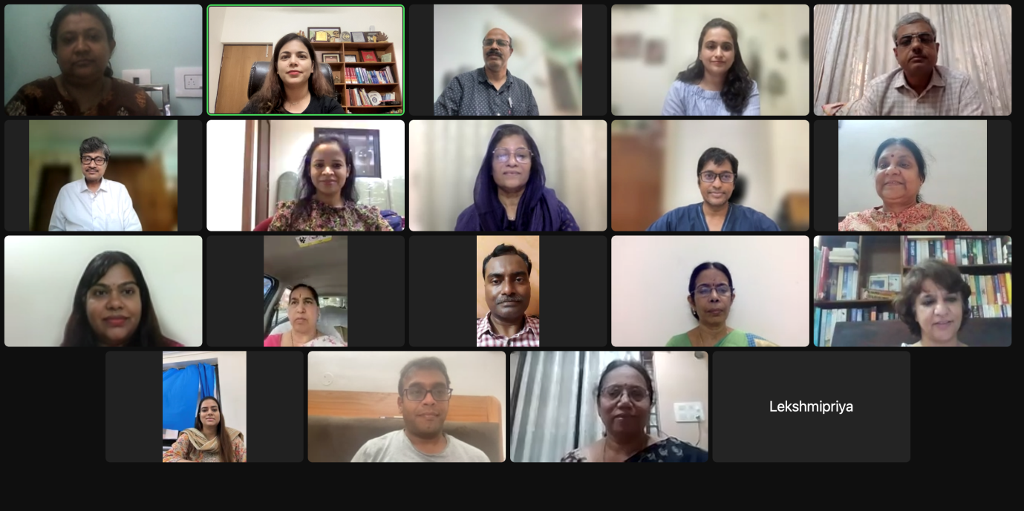
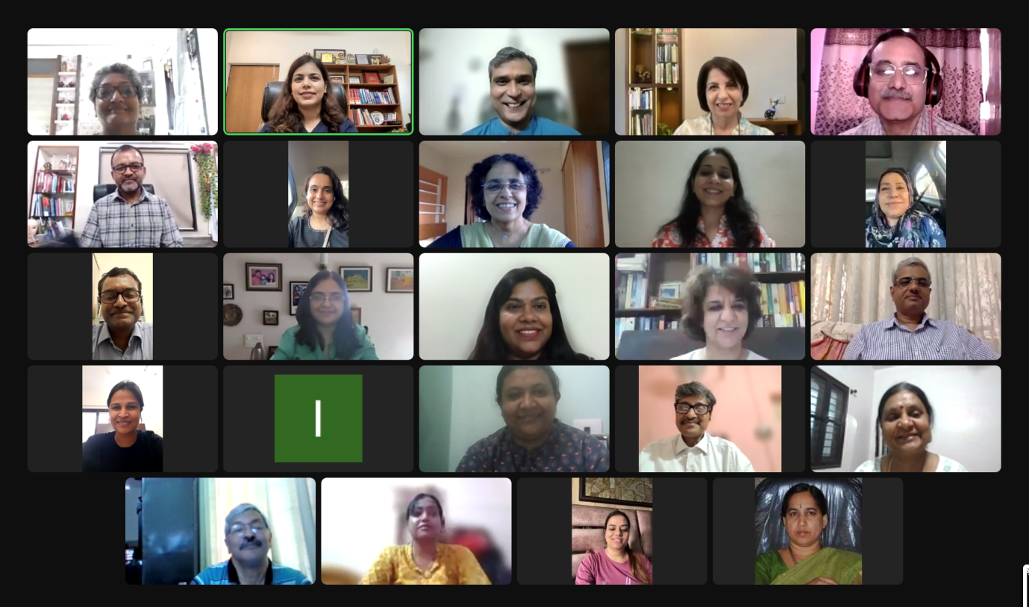
Constitution of a new taskforce “HIV & STDs”:
The new taskforce on HIV and STDs approved during the AGBM at Mumbai was constituted after following appropriate SOPs. Dr Leelavathi B has been appointed the coordinator and Dr Vinay Kulkarni the convener of the taskforce. The members are Dr Murugan Sankaranantham, Dr Rakesh Bharti, Dr Yogesh Marfatia, Dr Ravi Rathod, Dr Vikrant Saoji, Dr. Santoshdev Rathod, Dr Malathi Munisamy, Dr.Swastika suvirya and Dr Abhineetha.
IADVL Observerships
IADVL Observerships 2023 offered observership courses in different specializations under the able guidance of 26 course directors. Various courses offered were LASERS, Aesthetic dermatology, Dermatosurgery, Phototherapy, Trichology, Hair transplant Surgery, Urticaria, HIV medicine, Leprosy, Pediatric dermatology and Dermoscopy. Candidates were selected by application and screening process and 15 observers were selected from above 35 years age category while 88 candidates belonged to less than 35 year category. Currently, 24 observers (7 in above 35 years and 17 below 35 years category) have completed their observership. Stipend (for observers less than 35 years) and course completion certificates have been issued to the observers after receiving feedback from them as well as their course directors.
Announcement for application to the new Observership centers and course directors was released in April 2023 and we have received 6 applications. Announcement of renewal of the existing observership centers which were due for renewal was released in May 2023.
- Dr Jyothi Jayaraman and Dr K Lekshmipriya; IADVL Observerships Coordinators
IADVL International Dermatopathology Observerships
After a decision taken during AGBM at Mumbai, the five centers offering international dermatopathology observership were contacted to restart the observership. Two of them, UCSF, San Francisco and Mackay Memorial Hospital, Taipei, Taiwan have reverted with willingness to take IADVL nominated observers. We plan to soon announce the one month observership for 2023.

Second international leprosy training program at China:
Applications were invited for second leprosy training program to be held at China. After evaluation by academy, a team of eight members have been selected for the same and has been approved by IADVL EC. The team will attend a two weeks training in September.

Sister society sessions in International conferences:
Under IADVL EC guidance academy prepared the scientific session for the sister society to be held at World congress of dermatology 2023 (Singapore), SARCD 2023 (Colombo) and EADV 2023 (Berlin). The applications were asked from members and evaluation done by the selection committee.

IADVL Research Grants
For the year 2022, seven projects (6 for IADVL Research Grant & 1 for IADVL Glowderma Research Grant) were selected out of the 14 applications received at the IADVL research Grant Jury meeting held during mid-term Academy meeting on 18.06.2022. A total grant of 35,04,750 INR (IADVL) + 9,49,000 INR (Glowderma) has been sanctioned for these. Four of the researchers have submitted all documents and have been transferred first instalment.
For 2023, applications have been called on 23rd March for IADVL research grant for a total amount of Rs.50,00,000 and IADVL Glowderma grants for Rs 10,00,000. We received 25 IRG AND 10 IGRG [total 35] applications till May 26th which was the closing date for submission. The checked protocols were sent to DCR committee for review on 28th May. DCR had sent back the reviews to Research Grant coordinators on June 28th. These were communicated to the researchers and their revised proposals have been received. These will be discussed in the jury meeting to be held on 22nd & 23rd July for final allotment of funds.
- Dr Joyeetha Choudhary and Dr Vinay K; IADVL Research Grant Coordinators
IADVL Scholarships
This year scholarships were announced for World Congress of Dermatology, Singapore and 12 deserving candidates were awarded scholarship of 50,000/- each. Scholarships have also been announced for MIDDERMACON Calicut (30 in number, 15000/- each) and SARCD (30 in Number, 30000/- each). The last date of application is 5th August and 20th July respectively. Scholarships will also be announced for DERMACON 2024 soon.
Dr Rahul Kumar Sharma: IADVL Scholarship coordinators
IADVL Online Lectures
Twelve online training modules developed over 2020 and 2021 are active on the digital platform of the Academy page of IADVL. Each module has four video lectures followed by a MCQ based assessment test.
For the year 2022-23, six more modules have been finalized after taking feedback from academy members.
- Connective tissue diseases
- Vasculitis & vasculitis mimics
- Learning the basic skill of presentation and communication
- HIV & STDs
- Leprosy basics
- Dermatology nursing
The list of subtopics for each OTM has been finalized and the faculty is being contacted for final recording.
- Dr Sudha Rani; IADVL Online Lecture Series Coordinator
Scientific Program at National Conferences
MIDDERMACON, Calicut, 2023
SIG Acne & appendageal diseases and SIG Dermatosurgery will be organizing their sessions at MIDDERMACON 2023. They have finalized the scientific program, the same has been approved by the IADVL EC and the program has been communicated to the organizers. Academy members, shortlisted topics for two Academy focus sessions on ‘Emerging infections with cutaneous manifestations’ and “Artificial intelligence in dermatology: where do we stand!’. Applications were invited from IADVL members for these sessions. The evaluation was done by the academy members and the result was announced on 30th June. Ten students have also been selected to present their thesis work in the PG thesis based award paper session at MIDDERMACON 2023.

DERMACON Hyderabad, 2024
Five SIGs likely to hold their sessions in DERMACON 2024 were selected on a rotation basis. These are SIGs NTD, Dermoscopy, dermatopathology, DCR and pruritus. They will be requested to send suggested scientific program of 1 hour each. The proposed program will be discussed in academy and will be sent for EC approval. There will also be a research grant session and a PG thesis based award paper session.
Post Graduate activities

IADVL Postgraduate Thesis Grant
Of the 15 thesis grants approved for the year 2022, first instalment of 12 grants were transferred upon receipt of requisite of documents. Announcement for 25 grants for 2023 was done on April 29, 2023 with the last date of submission being June 6, 2023. 43 applications received have been sent to SIG DCR for evaluation and the final allotment will be soon announced.
PGCON 2023
For the year 2023 IADVL Academy and EC has planned to conduct a virtual PGCON to improve attendance of students. This will be held in November-December 2023.

PG Thesis Based Award Session
Applications were called for PG thesis-based award sessions at MIDDERMACON 2023 to be held at Calicut. Twenty applications were received. The abstracts were evaluated by the members of the IADVL Academy. The list of 10 selected applicants is announced. Applications for DERMACON 2024 will be soon announced.
-Dr Shekhar Nana Pradhan and Dr Ranugha PSS, IADVL Academy Postgraduate Activities Coordinator
IADVL Training Courses in Sub-specialties
For the year 2023, 68 applications were received and after evaluation by academy members (2021), 13 candidates were awarded IADVL Trainings. The list was approved in Closing AGBM at DERMACON 2023. They were communicated to submit their consent. The candidates are given a stipend of 10,000 INR per month for this three month course. One candidate has completed her training and three are currently pursing it. The training needs to be completed by 31st December.
New initiatives in 2023:
With support from IADVL EC, for 2023 many new initiatives have been started
- Monthly practitioner’s forum: To discuss and bridge the gap in practice between institutional and private practice. Two sessions with excellent member participation have been held in May and June.
- Dermatopathology Quiz based teaching: This is done by Dr Sasi Kiran (Member SIG Dermatopathology) once every two months in collaboration with Dermatopathology society of India and is well received by the post graduates.
- Dermatosurgery procedural videos: Short videos prepared by SIG Dermatosurgery are being shared with members and are uploaded on our website to help members learn basic Dermatosurgery procedures. Five videos are currently online.
- Flashcards and educational videos by taskforce biologics and small molecules: Flashcards on common drugs like Secukinumab, Apremilast, Rituximab etc will be prepared and shared. The one on Secukinumab has been already shared.
IADVL Publications
Books
This year four handbooks/ atlas will be prepared under presidential project. These are
•Bedside tests in Dermatology
•Therapeutic pearls & Anecdotal therapies in Dermatology
•Concise atlas of Internal diseases and cutaneous clues
Applications were invited and after evaluation by selection committee the editorial board for each was announced. The teams were communicated and they have been asked to submit the table of content for the books.
Newsletters
Newsletters by SIG Acne & appendageal diseases and SIG leprosy are in the final stages of typesetting and will be soon released.
- Dr Mala Bhalla ,IADVL Publications Coordinator

IADVL Academy ZOOM Webinar Platform
IADVL academy after approval from IADVL EC has subscribed to the Zoom Webinar (for 500 delegates) platform for 2023 also. A number of webinars have been conducted on this platform.
WORKSHOPS/CMEs conducted by the SIGs
IADVL SIG Activities
Dr Dr Abhishek Bhardwaj & Dr Kanika Sahni, IADVL SIG coordinators

SIG Acne & appendageal diseases:
Conducted two physical CME, one on 26th March, 2023 at Kolkata and the other on 18th June at Vapi, Gujarat. An educational poster was prepared on skin health day on healthy practices for acne prone skin.
(Dr Nina Madnani, Coordinator; Dr Rochelle Monteiro, Convener)
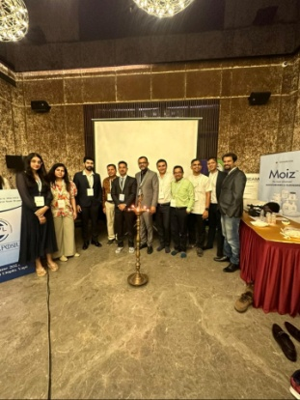

SIG Aesthetics
Planned 6 Hands-on workshops as a part “ Excellence in aesthetics injectables” initiative. These hands-on workshops will give an opportunity to IADVL members to gain a hands-on experience of botulinum toxin and fillers. The scientific content has been prepared by the SIG and approved. The first workshop of the series will be conducted at Jaipur on July 23rd. Patient Information pamphlet busting myths about Botox was prepared on the occasion of Skin Health Day. ACAD forum activity for 3 weeks pertaining to Asthetic Dermatology was conducted by members. IADVL Yuva Cell collaboration on “ Ask the Expert” was done and Instagram live activity was performed.
(Dr Gulhima Arora, Coordinator; Dr Rajat Kandhari, Convener)
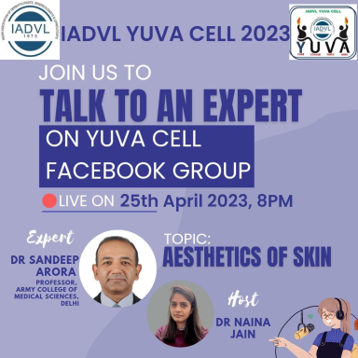
SIG Dermatology Clinical Research
Evaluated IADVL research grant proposals 2023, wherein 35 applications were received. SIG DCR conducted a 1 day CME cum Workshop on Systematic Review and Meta-analysis at Dr BR Ambedkar Medical College and Hospital, Bangalore. The IADVL PG thesis research grant are being evaluated by them.
(Dr Ajithkumar K, Coordinator; Dr Divya Gupta, Convener)
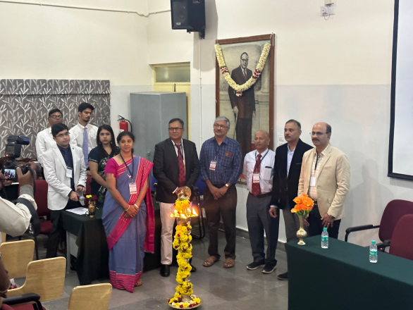

SIG Dermatopathology
Combined CME of SIG Dermatopathology and SIG Dermoscopy conducted at Bangalore, on 30th April 2023 with 120 attendees. Conducted “Image of the month” for April, May and June 2023 and uploaded on IADVL website. Conducted Dermatopathology online Quiz based teaching on 26th April 2023 and 28th June, 2023 by quiz master Dr Sasi Attili (virtual). Twenty more slides were added in digital slide library.
(Dr Meghana Phiske, Coordinator; Dr Geeti Khullar, Convener)
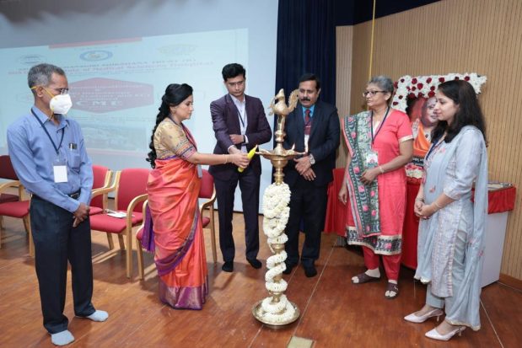
SIG Dermatosurgery
SIG has planned a series of four zonal workshops, PGPDT. The first one will be conducted at Hyderabad on 23rd July. The remaining three are planned at New Delhi, Surat and Kerala. SIG has also prepared short educational videos of common Dermatosurgery procedures that are being uploaded on our website.
(Dr Yogesh Bhingradia, Coordinator; Dr Nitin Jain, Convener)
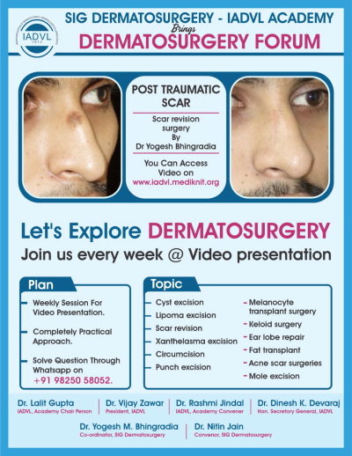
SIG Dermoscopy
Conducted the sixth basic Dermoscopy masterclass on onychoscopy on 13th April. An advanced masterclass series will be initiated from July that will be conducted once in three months. SIG has also initiated a Dermoscopy email helpline and is helping members with their Dermoscopy based queries.
(Dr Yasmeen J Bhat, Coordinator; Dr Bishwanath Behera, Convener)
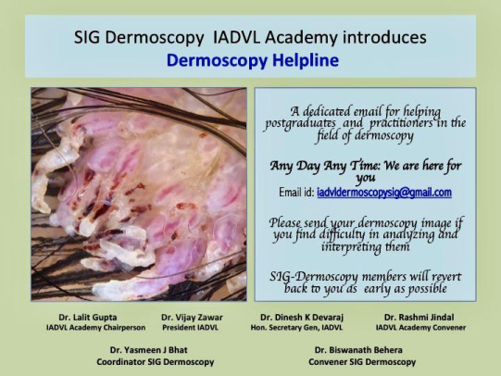

SIG Female Genital Dermatoses
A hybrid CME was conducted at Patiala. Two virtual journal club sessions have been organized by the SIG in March and May and were well received by members. Three posters were also prepared on common hygiene.
(Dr Dhanashree Bhide , Coordinator; Dr Rashmi Mahajan, Convener)
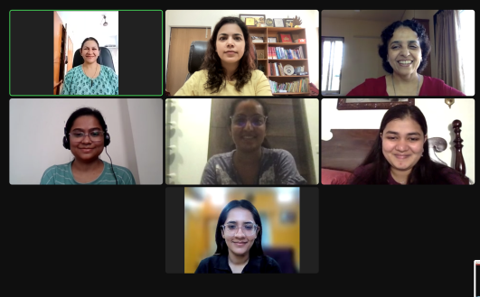

SIG Lasers
Four physical CMEs have been planned with the first one being conducted at Ahmedabad on 23rd July.
(Dr David Pudukadan, Coordinator; Dr Rahul Pillai, Convener)
SIG Leprosy
Have prepared the newsletter that is in final stage of publication. A short report on MIP vaccine in leprosy is also under review. The SIG has planned four CMEs during second half of the year.
(Dr Sunil K Gupta, Coordinator; Dr Swetalina Pradhan, Convener)
SIG Neglected Tropical Diseases
Conducted a webinar in collaboration with dermatology nursing taskforce on International nurses day 12th May. A physical CME was conducted at Shillong on 11th May, 2023.
(Dr Tarun Narang, Coordinator, Dr Shagufta Rather, Convener)
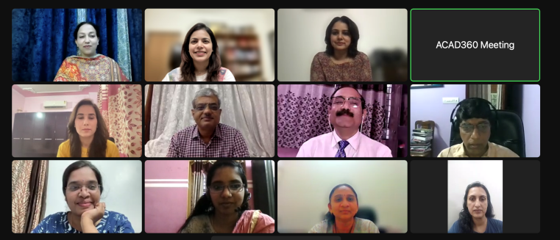
SIG Pediatric Dermatology
A hybrid CME was conducted on 6th May at Srinagar. PEDDERMACON 2023 is being conducted as a National event on 29-30 July 2023 with over 50 faculty members from across country. The rare disease registry was launched and is being running successfully. A handbook on use of immunomodulators in children is planned to be released this year. The team is also working on conducting two research projects.
(Dr Rahul Mahajan, Coordinator; Dr Maitreyee Panda, Convener)
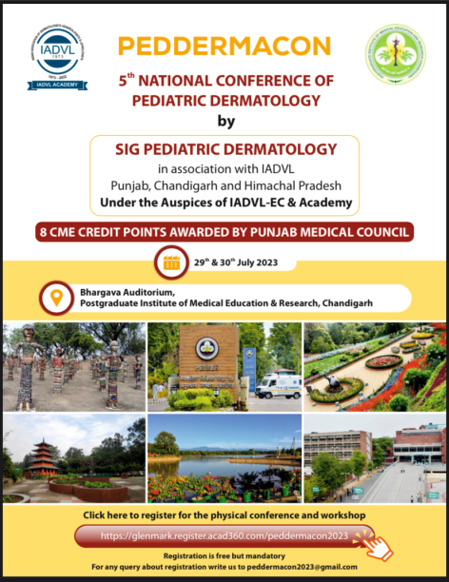

SIG Pigmentary Diseases
Case discussion on ACAD group was done by 5 members of the group in April. The SIG has planned four physical CMEs in coming months.
(Dr Pooja Mrig, Coordinator; Dr Pragya Nair, Convener)
SIG Pruritus
Has planned to conduct three physical CMEs and three virtual webinars in coming months. One of the physical events will be conducted during MIDDERMACON 2023 at Calicut
(Dr Najeeba R, Coordinator; Pradeep Kumar, Convener)

SIG Psoriasis
Webinar on Current understanding and future directions was conducted on 30th May. The program was well attended and was much appreciated. Four physical CMEs are planned in coming months.
(Dr Sudip Das, Coordinator; Dr Venkatachalam K, Convener)
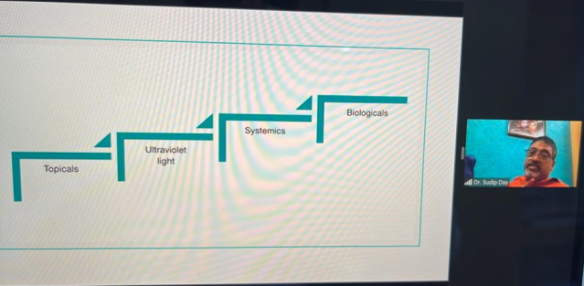
SIG Recalcitrant Dermatophytosis
Has planned four physical CMEs in coming months.
(Dr Madhu R, Coordinator; Dr Atiya Yaseen, Convener)
SIG Trichology and HT
SIG will be conducting four physical events. The first one is planned at Chandigarh on 23rd July.
(Dr Syed Mubashir, Coordinator; Dr Pradeep Kumari, Convener)
Taskforce Dermatology Nursing:
Conducted a webinar in collaboration with SIG NTD on International nurses day 12th May. A physical CME was conducted at Shillong on 11th May, 2023. The team is also working on the curriculum for dermatology nursing. A focussed webinar for residents is planned on 5th September. A 20 min session will also be conducted at MIDDERMACON Calicut.
(Dr S R Narahari, Coordinator)
Taskforce Biologics & small molecules:
The taskforce will conducting webinar and physical CMEs in the coming month. They have prepared flashcards and videos on commonly used biologics and small molecules that will be sequentially released.
(Dr Vishalakshi V, coordinator; Dr Shekhar Neema, Convener)
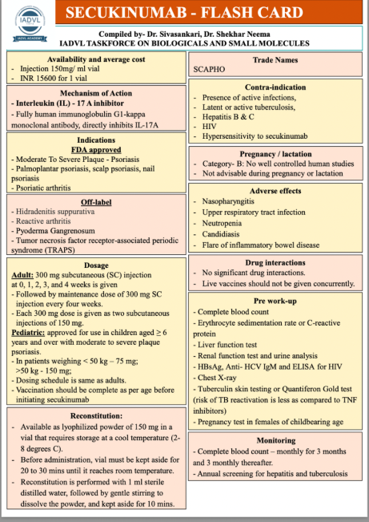
Taskforce HIV & STDs:
The newly constituted taskforce has prepared their roadmap. A dedicated whatsapp group has been started to discuss about HIV & STD cases. The member strength has reached 685. The team will be conducting quizzes and webinars in coming months.
(Dr Leelavathy B, Coordinator & Dr Vinay Kulkarni, Convener)

Core Academy Activities
- Webinar on skin and food allergy on 19th May during the food allergy week.
- A day long E-vitiligo symposium was conducted on World vitiligo day 25th June, 2023. The event was attended by over 2000 delegates and it was awarded5 credit points by Uttarakhand Medical Council.
- A painting competition was also conducted to commemorate the world vitiligo day. Over 77 entries received were evaluated and 13 best chosen will be converted into a commemorative postal stamp and IADVL calendar 2024.
- Two sessions of practitioner’s forum on tofacitinib and recalcitrant ENL in May and June.
- An International speaker Urticaria webinar on updates in urticaria management and care was conducted in association with GA2LEN on 14th July, 2023 with over 2500 attendees. Dr Marcus Maurer and Dr Torsten Zuberbier were the invited guest faculty.

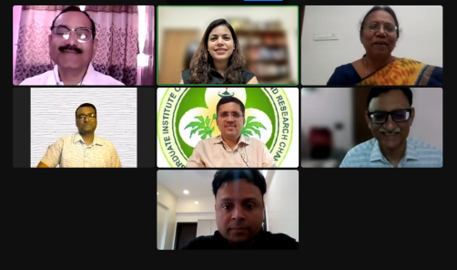
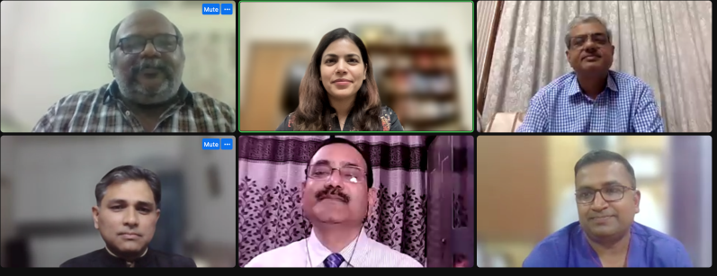
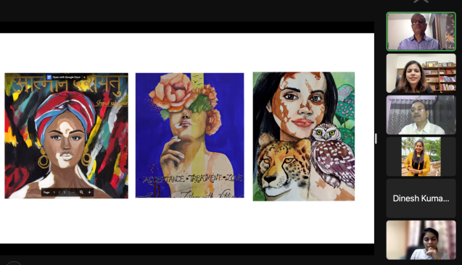
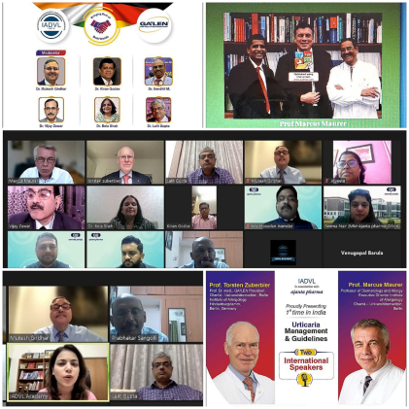
The IADVL academic activities calendar for the year 2023-24.
An all inclusive calendar was shared with all members including the tentative dates and venue of all future IADVL Academic activities planned. It has information about the virtual as well as physical events. We hope this will help members plan better. This was possible due to the dedicated work the SIGs and taskforces. IADVL Academy would also like to thank state branches for their support and cooperation.
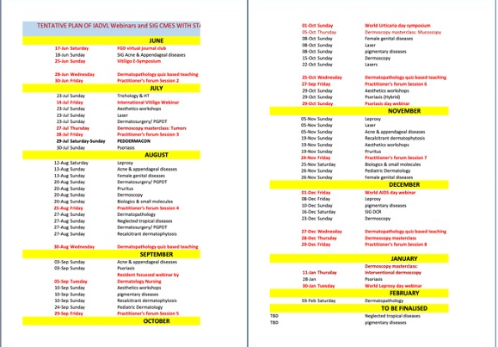

IADVL E-Library
Articles from the following specified journals are available by sending a request to iadvlejournals2015@gmail.com. This was informed to all e groups and to all members through state executives.
- Journal of Cutaneous Pathology
- Pediatric Dermatology
- The Journal of Dermatology
- Journal of the European Academy of Dermatology and Venereology
- International Journal of Dermatology
Journals are accessed from the website www.onlinelibrary.wiley.com
Dr Sudipta Roy, IADVL E library coordinators
Academy Account
All the research grants, scholarships, Observerships stipends are reimbursed from the IADVL Academy account at Rishikesh (Uttarakhand). According to the decision taken by central finance committee the payments for digital academy platform and CMEs will also be done through the academy account. A monthly statement with all receipts are being submitted to the treasurer regularly.

Receipts | Amount | Expenditure | Amount
Opening balance | 9,89,437.4 | Bank Charges | 35.40
Received from IADVL | 35,00,000 | Observership Expenses  Trainings expenses | 70,000  30,000
Interest Received from Bank | 14,294 | PG Thesis Grant Expenses | 1,88,069
 |  | IADVL Research Grant | 5,71,625
 |  | Scholarships | 11,25,000
 |  | Office Assistant Salary (March-June 2023) | 40,000
 |  | PG thesis award DERMACON 2024 | 36,000
 |  | Reimbursement for Travel and stay for faculty for IADVL CMEs | 1,26,612
 |  | Digiscan subscription histopath slides | 12,980
 |  | CME points vitiligo symposium | 6,050
 |  | Zoom subscription | 87,556
 |  | Printer | 2,230
Total | 45,03,731.4 | Total Expenses  Closing balance | 22,96,157.4  22,07,574

Dr Lalit Gupta (Chairperson, IADVL Academy)
Dr Rashmi Jindal (Convener, IADVL Academy)

