IADVL Academy Report, March 16th to July15th 2022 (second quarter)
Midterm Academy Meeting
A 2 days Midterm meeting of the Academy was held physically after a gap of two yearson 18th and 19thJune2022at the IADVL Headquarters.IADVL President, Dr Rashmi Sarkar, Academy Chairperson, Dr Lalit K Gupta, Hon’ Sec General, Dr Dinesh Devraj welcomed all the participants. The meeting on day one i.e., 18th June began with Academy members and the Jury members to discuss critically the projects submitted for IADVL Research Grant 2022 and IADVL Glowderma Research Grant 2022. This was followed by brainstorming discussion on several important issues like IADVL observerships, scholarships, workshops, activities for postgraduates, Academy publications, IADVL e-library, Academy budget and account. The meeting of Academy with SIGcoordinators was held next day i.e. on June19, 2022at the IADVL Headquarters. The activities planned by all 16 SIGs and the two taskforces (Dermatology nursing and biologics and small molecules) were discussed in details.The meeting ended with a vote of thanks by IADVL convener, Dr Rashmi Jindal.
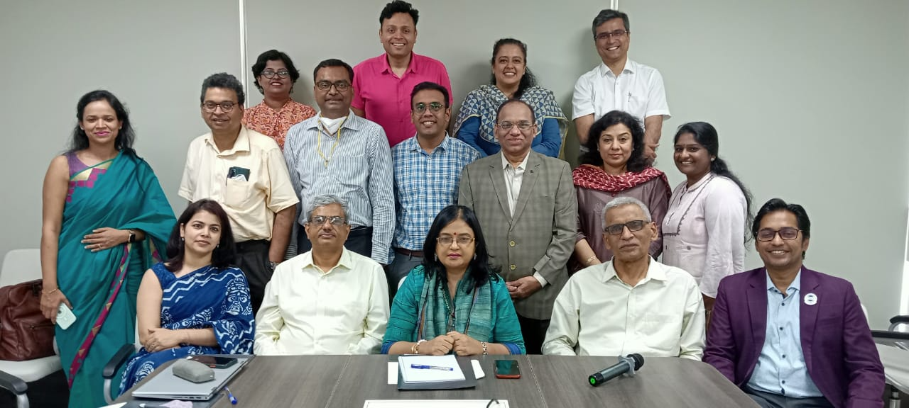
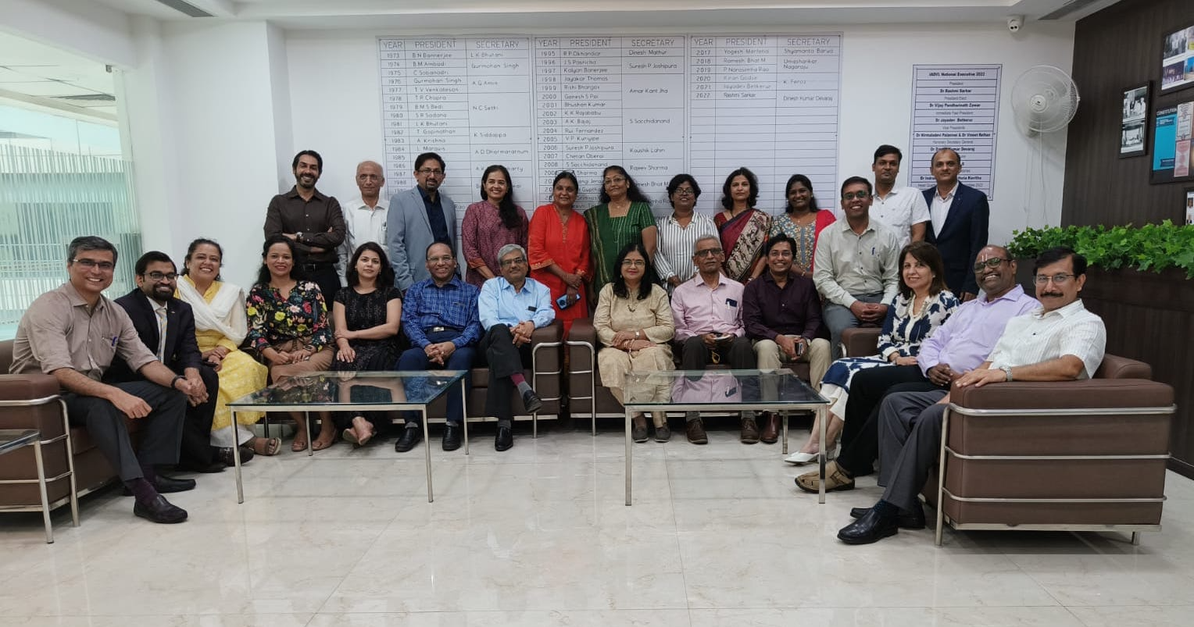

Constitution of a new SIG on Acne & Appendageal diseases:
SIG acne and appendageal diseases was constituted. Dr Nina Madnani and Dr Rochelle Monteiro were appointed the coordinator and convenor respectively with a team of seven members.
Dr Abhishek Bhardwaj, Dr Pooja Arora Mrig, IADVL SIG Coordinators
Constitution of Taskforces:
Two taskforces have been constituted, Dermatology nursing and biologics & small molecules. Dr S R Narahari and Dr Hita Mehta have been appointed coordinator and convenor respectively for dermatology nursing taskforce. Dr Vineet Kaur will serve as advisor and the members are Dr Rashmi Mahajan, Dr Sivsankari M, Dr Farzana Ansari, Dr Preethy Harrison and Dr Sushruth G Kamoji. Dr Vishalakshi Vishwanath and Dr Shekhar Neema have been appointed the coordinator and convenor respectively for biologics and small molecules taskforce.The members are Dr Abhishek De, Dr Krina Patel, Dr Gautam Kumar Singh, Dr Dipali Rathod, Dr Sivsankari M, Dr Ratnakar Shukla, Dr Farzana Ansari and Dr Samkit Shah.
IADVL Observerships
Observerships are given at each centre for a duration of 4 weeks (and a stipend of Rs 10,000), for IADVL PLMs or LMs aged less than 35 years and for a duration of 2 weeks (without a stipend), for IADVL LMs aged 35 years or above. 43 candidates of 2020 and 70 candidates of 2021 completed their observership till 31st March, 2022.
A total of 226 applications were received for 2022 out of which 70 observerships were allotted (50 for <35 years & 20 for >35 years) to the28centres offering observership in diverse fields for the year 2022, 52candidates confirmed their slots for observership. Of the consenting candidates, 13 have already completed their observership. A WhatsApp group that includes the program directors, observers, the Academy chairperson, convener and coordinators of the observership program has been created to facilitate the coordination between different stakeholders. This year the feedbacks from observers as well as the directors will be collected using google forms to streamline the process.
- Dr Bhabani Singh and Dr Malathi M; IADVL Observerships Coordinators
IADVL International Dermatopathology Observerships
Four of the five centres offering International Dermatopathology observership had expressed their inability to train candidates during 2022 with no clarity expressed on their future training status due to the COVID-19 pandemic. Thus, IADVL EC and AGBM agreed to keep IADVL International Dermatopathology observership on hold till further clarity from the training institutes is obtained. The previously selected candidates were informed of this decision and in future they will be allowed to reapply.

IADVL Research Grants
For the year 2021, 10 projects were selected out of the 29 applications received at the IADVL research Grant Jury meeting held during mid-term Academy meeting on 10.07.2021. For IADVL Glowderma Research Grant a total of 2 projects were selected out of 13 received. A total grant of 47,05,187 INR (IADVL) + 9,41,057 INR (Glowderma) has been sanctioned for these. After fulfilling all the requirements, the first installment of 4 of the 12Research grant projects has been disbursed till date. During the period of reporting, second instalment was also transferred to 1 project that received the IADVL research Grant 2020.

IADVL- Research Grants 2022
Fourteen applications were received for the IADVL research Grant 2022 and Four applications were received for the IADVL Glowderma Research Grant 2022. The members of the SIG Dermatology Clinical Research gave critical inputs for improvement of the proposals. The revised projects were resubmitted and sent to the Jury members for appraisal. The jury meeting was held on June 18, 2022 and seven projects have been shortlisted. The applicants of the shortlisted projects will be communicated the Jury comments and the final approval of grant will be subject to satisfactory response to Jury comments.
- Dr Chander Grover and Dr Joyeetha Choudhary; IADVL Research Grant Coordinators

IADVL Scholarships
MIDDERMACON 2022 and DERMACON 2023
This year scholarships for DERMACON international 2023 (99, 15000 INR each), and MIDDERMACON 2022 (30, 15000 INR each) will be awarded. Thescholarships for MIDDERMACON 2022 will be announcedsoon.Scholarships have also been announced for International Leprosy Congress 2022. The applications have been received and will be evaluated by SIG Leprosy. The result will be announced thereafter.
- Dr Rahul Kumar Sharma: IADVL Scholarship coordinators

IADVL Online Lectures
Twelve online training modules developed over 2020 and 2021 are active on the digital platform of the Academy page of IADVL. Each module has four video lectures followed by a MCQ based assessment test.
For the year 2022, six more modules have been finalized after taking feedback from academy members.
- Connective tissue diseases
- Vasculitis & vasculitis mimics
- Learning the basic skill of presentation and communication
- HIV & STDs
- Leprosy basics
- Dermatology nursing
The list of subtopics for each OTM has been finalized and the faculty is being contacted.
- Dr Nirupama Bhagya Lakshmi Tatavarthi; IADVL Online Lecture Series Coordinator

Scientific Program at National Conferences
MIDDERMACON, Lucknow, 2022
SIG Psoriasis and SIG Pigmentary diseaseswill be organizing their sessions at MIDDERMACON 2022. They have finalized the scientific program,the same has been approved by the IADVL EC and the program has been communicated to the organizers. Academy members, shortlisted topics for two Academy focus sessions on ‘Updates in dermatology therapeutics’ and ‘Emergency dermatology’. Applications were invited from IADVL members for these sessions. The evaluation was done by the academy members and the result will be soon announced.

DERMACON Mumbai, 2023
Five SIGs likely to hold their sessions in DERMACON 2023 were selected on a rotation basis. These are SIGsfemale genital dermatoses,leprosy, pediatric dermatology, lasers, aesthetics . They will be requested to send suggested scientific program of 1 hour each. The proposed program will be discussed in academy and will be sent for EC approval.

Post Graduate activities

IADVL Postgraduate Thesis Grant
Of the 20 thesis grants approved for the year 2021, first instalment of 15 grants and both instalments for one grant were transferred upon receipt of requisite of documents. Due to the delay in NEET PG counselling, call for grants was not announced in 2021, IADVL Academy proposed that 30 PG thesis grants will be announced for the year 2022 (split between the post graduates joining in 2021 and 2022). The same was approved at AGBM DERMACON 2022. Announcement for 2021 candidates was done on May 12, 2022 with the last date of submission being July 15, 2022. 39 applications received will be evaluated by SIG DCR and finally 15 candidates will be selected.

PGCON 2022
For the year 2022 IADVL Academy is discussing with IADVL EC regarding the mode of conduct of PGCON. There is a possibility of conducting a central web-based PGCON and will be finalized soon.

PG Thesis Based Award Session
Applications were called for PG thesis-based award sessions at MIDDERMACON 2022to be held at Lucknow. Twenty-three applications were received. The abstracts were evaluated by the members of the IADVL Academy. The list of 10 selected applicants is announced.
Applications for DERMACON 2023 will be soon announced.
-Dr Shekhar Nana Pradhan and Dr Ranugha PSS, IADVL Academy Postgraduate Activities Coordinator
IADVL Abbott Researcher Award
This award is given for published research (original research articles) with a cash prize of Rs 25,000 each for one researcher upto 35 years of age and one above 35 years of age, along with a certificate. The evaluation is done by Academy members using a pre-decided scoring sheet. The articles are presented in the IADVL Research Grant Session during DERMACON. The announcement calling for applications for these awards shall be made soon.
IADVL Training Courses in Sub-specialties
For the year 2022, 78 applications were invited in 2021 for the seven training centers and after evaluation by academy members (2021), 13 candidates were awarded IADVL Trainings. The list was approved in Closing AGBM at e DERMACON 2022. They have been communicated to submit their consent. The candidates are given a stipend of 10,000 INR per month. Two of the 13 candidates have completed their training.
IADVL Golden Jubilee Derm-podcasts:
As a presidential initiative, this year around 50 podcasts are being aired. From Academy, 20 podcasts on diverse and interesting dermatological topics will be aired as a short audio clips of 15-20 minutes duration. Eleven are already on-air.
- Care of the newborn skin (Dr Sandipan Dhar & Dr Chander Grover)
- Photography in dermatology (Dr Manas Chatterjee & Dr Pooja Arora)
- Artificial intelligence in dermatology (Dr Venkataram Mysore & Dr Rashmi Jindal)
- Urticaria management (Dr Kiran Godse & Dr Abhishek De)
- Psoriasis: an Indian perspective (Dr Abir Saraswat & Dr Abhishek Bhardwaj)
- Small molecules & their potential in dermatology (Dr Brijesh Nair & Dr Shekhar Neema)
- Leprosy care in India & Dermatologists (Dr P Narasimha Rao & Dr Santoshdev P Rathod)
- Scientific approach in vasculitis & vasculopathy. (Dr Sujay Khandpur& Dr Rahul Kumar Sharma)
- Vitiligo an Indian scenario (Dr Davinder Prasad & Dr Vinay Keshavmurthy)
- PCOS and its unconventional forms (Dr NitiKhunger& Dr Krati Mehrotra Dewan)
- Q switched lasers: Then and now (Dr Anil Ganjoo& Dr Anurag Tiwari)

Monthly PG Quiz by SIGs:
A monthly PG Quiz will be conducted by the SIGs. This will be conducted on the last Friday of each month. First quiz will be conducted on 29th July, 2022 by SIG female genital dermatoses.
IADVL Publications
Books
Announcement of the editorial board for IADVL Presidential project book entitled “Pemphigus & Immuno-bullous diseases” was made. The table of content was approved by Academy and EC. The final author selection is underway and will be announced soon.
Announcement for authors of the book “Second edition of the IADVL manual on management of dermatophytosis” will be soon made, the list has been approved by IADVL EC.

Newsletters
Newsletters by SIG Dermoscopy, Aesthetics, Dermatosurgery, female genital diseases, recalcitrant dermatophytosis and taskforce biologics and small molecules are in the final stages of typesetting and will be soon released.
- Dr Devi K ,IADVL Publications Coordinator

IADVL Academy ZOOM Webinar Platform
IADVL academy after approval from IADVL EC has subscribed to the Zoom Webinar (for 500 delegates) platform. This step was taken to conduct additional academic activities without need of sponsors. SIGs have been communicated regarding the same and will plan their future activities accordingly. SIG Dermoscopy is conducting Master-class in Dermoscopy once in a two months. SIG FGD also conducted their webinar using this platform.SIG DCR has been conducting virtual JC on this platform every two months.
WORKSHOPS/CMEs conducted by the SIGs
IADVL SIG Activities
Dr Pooja Arora Mrig and Dr Abhishek Bhardwaj, IADVL SIG coordinators

SIG Acne & appendageal diseases:
Conducted a physical CME on 10th July, 2022 at Mumbai. Another one is planned at Vadodara in association with IADVL Gujarat branch in the month of August.
(Dr Nina Madnani, Coordinator; Dr Rochelle Monteiro, Convener)

SIG Aesthetics
Planned 10 Hands-on workshops as a part of Presidential Project on “ Excellence in aesthetics injectables”. These hands-on workshops will give an opportunity to IADVL members to gain a hands-on experience of botulinum toxin and fillers. The scientific content has been prepared by the SIG and approved. The first workshop of the series will be conducted at New Delhi on July 31st.
(Dr Gulhima Arora, Coordinator; Dr Rajat Kandhari, Convener)

SIG Dermatology Clinical Research
Evaluated IADVL research grant proposals 2022, wherein 18 applications were received. They have started and conducted successfully two virtual journal clubs using the Academy Zoom webinar platform. This activity has got excellent feedback from our members. They also conducted a webinar on “Planning a thesis proposal” on 29th June to help the students as well guides. They are also planning a full-day research methodology workshop with Kerala branch.
(Dr Ajithkumar K, Coordinator; Dr Divya Gupta, Convener)

SIG Dermatopathology
Conducted physical CMEs at New Delhi, Shillong and Ahmedabad. Started the monthly activity “Image quiz by SIG Dermatopathology” where clinical as well as histopathology image of a case is shared with embers and the answers are then explained with announcement of the results. They have also proposed to develop a digital slide collection for the benefit of post-graduate students. This was approved by academy and EC and is under process. The link to access these common slides will be available on the academy page.
(Dr Meghana Phiske, Coordinator; Dr Geeti Khullar, Convener)

SIG Dermatosurgery
SIG has planned a series of four zonal workshops, a primer for PGs.The first one was conducted at Bhubaneshwar with excellent feedback and attendance. The next one is planned at Surat in the month of August. Participated in the conduct of Vitiligo e-symposium.
(Dr Nilesh Goyal, Coordinator; Dr Syed Mubashir, Convener)

SIG Dermoscopy
Started with Dermoscopy masterclasses, two of them one on Dermoscopy basics and the other on pigmentaroscopy have been conducted. They have also planned two physical CMEs, one at Srinagar and the other at Bhubaneshwar in September and August respectively. They have also submitted a research proposal for consideration of IADVL Research Grants 2022.
(Dr Yasmeen j Bhat, Coordinator; DrBishwanath Behera, Convener)

SIG Female Genital Dermatoses
Conducted a webinar on Practical aspects of vulvar dermatoses. Conducted physical CMEs at Pune and Gujarat.
(Dr Smitha Prabhu, Coordinator; Dr Pragya Nair, Convener)

SIG Lasers
Planned physical CMEs in the month of August.
(Dr David Pudukadan, Coordinator; Dr Rahul Pillai, Convener)

SIG Leprosy
Have planned a webinar on “Leprosy sensitization: for nurses and physiotherapists” on 23rd July. SIG Leprosy will be participating in International Leprosy Congress 2022 by conducting the quiz as well as by evaluating the scholarships.
(Dr Tarun Narang, Coordinator; Dr Sunil Kumar Gupta, Convener)
SIG Neglected Tropical Diseases
Conducted a webinar in association with IADVL Chhattisgarh on 22nd May. Also planned a physical CME at New Delhi in the month of August.
(Dr P. Narasimha Rao, Coordinator, Dr Parul Verma, Convener)

SIG Pediatric Dermatology
Conducted rare disease day CME virtually on 27th February. A physical CME was conducted at Bhubaneshwar in association with IADVL Orissa. They have planned Pedermacon 2022 in association with IADVL GSB in November and two webinars obpediatric atopic dermatitis and pediatric psoriasis in the month of September and October respectively.
(Dr Rahul Mahajan, Coordinator; Dr Maitreyee Panda, Convener)

SIG Pigmentary Diseases
SIG will be conducting a one hour session at MIDDERMACON. The scientific program was prepared and approved. They have planned to conduct two physical CMEs, one at Amritsar and the other at Mysuru in coming months. Participated in the conduct of Vitiligo e-symposium as well as the physical melasma CME on 17th June, 2022 at New Delhi.
(Dr M. Sendhil Kumaran, Coordinator; Dr Chethana Gurumurthy, Convener)
SIG Pruritus
Has planned to conduct a webinar in association with IADVL Bihar by the end of July.
(Dr Asit Mittal, Coordinator; Brigadier Rajesh Verma, Convener)

SIG Psoriasis
Planned a physical CME at Hyderabad on July 27th. SIG will also participate in MIDDERMACON 2022, a one hour scientific program was submitted and approved. They will be conducting two more physical CMEs this year, one at Mumbai and other at Bhubaneshwar.
(Dr Sushil Tahiliani, Coordinator; Dr Bikash Ranjan Kar, Convener)
SIG Recalcitrant Dermatophytosis
Participated in the recalcitrant dermatophytosis webinar on 29th May. Helped in developing and finalizing the content of the sponsored Hello skin initiative to improve patient compliance to treatment. Have planned to conduct four physical CMEs in the coming months.
(Dr Madhu R, Coordinator; Dr Nayankumar H Patel, Convener)

SIG Trichology and HT
Conducted four physical workshops at Hyderabad, Mangalore, Jaipur and Mumbai. Have planned to conduct four more CME/ worshops in the coming months. Helped the IADVL EC in drafting a brief document on who could perform a hair transplant, the same was presented to the Registrar, Delhi Medical Council by National President, Dr Rashmi Sarkar.
(Dr Kavish Chouhan, Coordinator; Dr Kuntal Deb Barman, Convener)
Taskforce Dermatology Nursing:
The taskforce will be preparing an online training module for dermatology nursing.
(Dr S R Narahari, Coordinator; Dr Hita Mehta, Convener)

Taskforce Biologics & small molecules:
The taskforce will conducting webinar and physical CMEs in the coming month. They have planned to develop guidelines on the use of biologics and small molecules in the Indian context.
(Dr Vishalakshi V, coordinator; Dr Shekhar Neema, Convener)

Core Academy Activities
- Webinar on Art of quizzing in association with IADVL AP
- Webinar on approach to leg ulcers in association of IADVL AP
- Webinar on Dermatophytosis was conducted on 29th May, 2022 with participation from SIG recalcitrant Dermatophytosis.
- A hybrid Melasma CME was conducted at New Delhi on 17th June, 2022. It was attended by 80 physical delegates and 1400 virtual delegates.
- IADVL National Vitiligo e-symposium on the occasion of World Vitiligo Day 2022, was held on June 25, 2022 with a huge success. SIG Pigmentary diseases and SIG Dermatosurgery participated in the scientific program. The full day program comprised talks, panel discussions, and a quiz. Two overseas faculty also participated along with the national faculty.

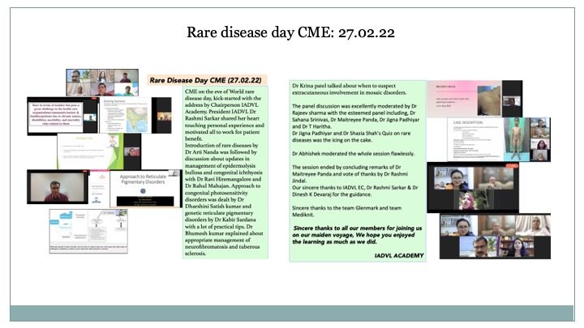
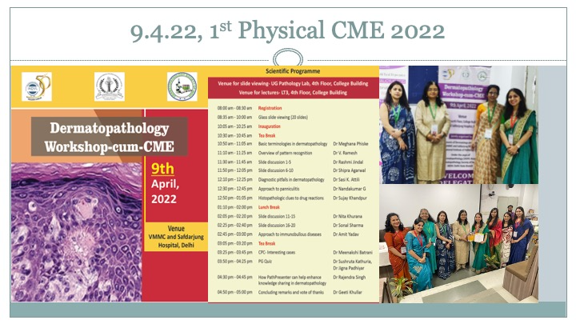
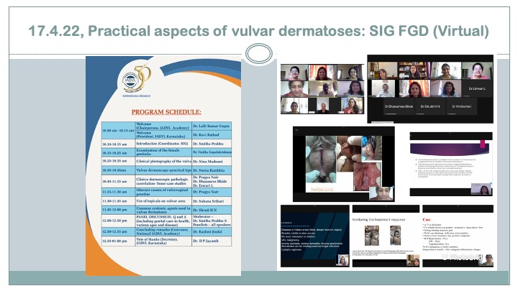
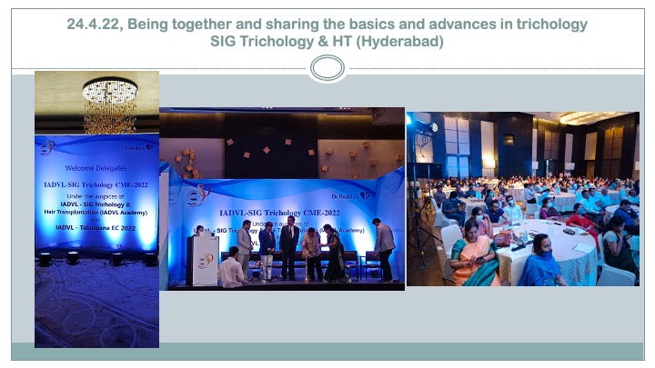
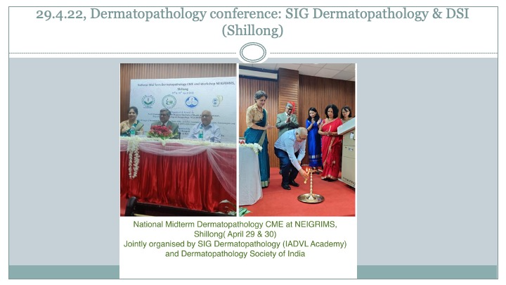
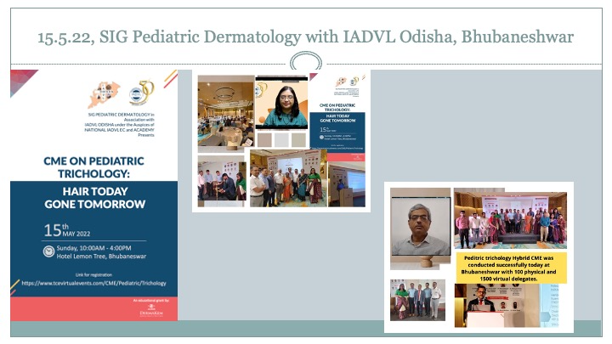
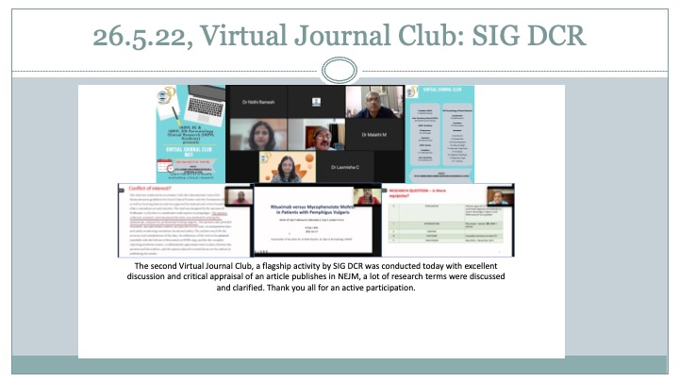
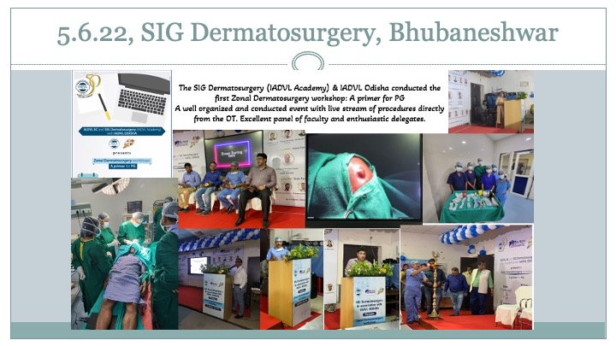
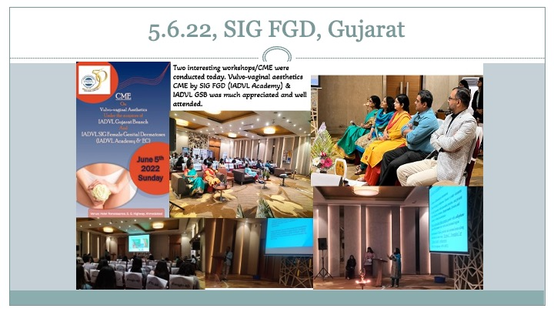

IADVL E-Library

Articles from the following specified journals are available by sending a request to iadvlejournals2015@gmail.com. This was informed to all e groups and to all members through state executives.
- British Journal of Dermatology
- Dermatologic Therapy
- Journal of Cutaneous Pathology
- Pediatric Dermatology
- The Journal of Dermatology
- Clinical & Experimental Dermatology
- Journal of the European Academy of Dermatology and Venereology
- International Journal of Dermatology
Journals are accessed from the website www.onlinelibrary.wiley.com
Dr Vinay Keshavmurthy, IADVL E library coordinators

Academy Account (opened at Rishikesh on 24th April, 2022)
All the research grants, scholarships, Observerships stipends are reimbursed from the IADVL Academy account at Rishikesh (Uttarakhand).

Receipts | Amount | Expenditure | Amount
Opening balance (transferred from Chandigarh account) | 6,68,639 | Bank Charges | 212.40
Received from IADVL | 29,00,000 | Observership Expenses | 1,50,000
Interest Received from Bank | 1,499 | PG Thesis Grant Expenses | 0
 |  | IADVL Research Grant | 1,40,000
 |  | Scholarships | 00
 |  | Office Assistant Salary (June, 2022) | 10,000
 |  | Reimbursement for Travel MIDTERM Academy Meeting 2022 | 3,25,275
Total | 35,70,138 | Total Expenses | 6,25,487.40

Dr Lalit Gupta (Chairperson, IADVL Academy)
Dr Rashmi Jindal (Convener, IADVL Academy)

